Findings from the data analysis of Power Co data

# Validating the price sensitivity hypothesis

## Base price sensitivity

Price fluctuations during peak and off-peak seasons affect consumer churn. Paying a higher price during the off-peak season as compared to the peak season increases the chances of churning in 3 months as shown by the curves below:

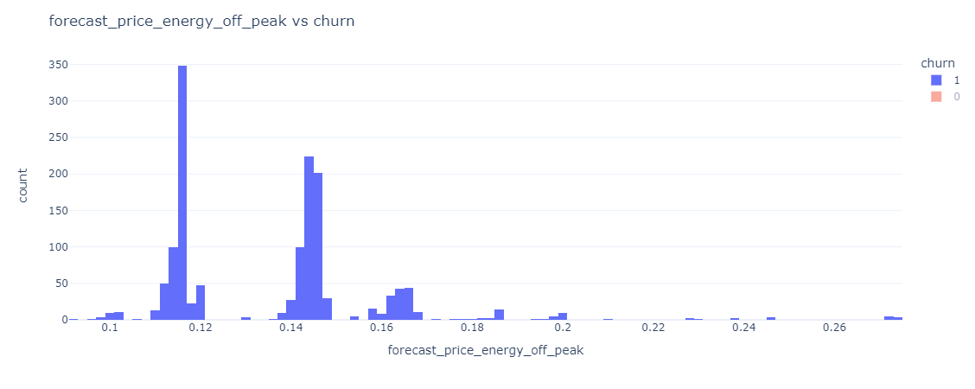

Figure 1: Correlation between off-peak energy prices (forecasted) and churn values.

Figure 2: Correlation between peak energy prices (forecasted) and churn

Furthermore, lack of discounts offered to the consumers also resulted in increasing the churn:

Figure 3: Correlation between discounts offered and the churn rate of consumers